A000-Am,C-Taino-Pendant-Owl-Bone-1000 CE

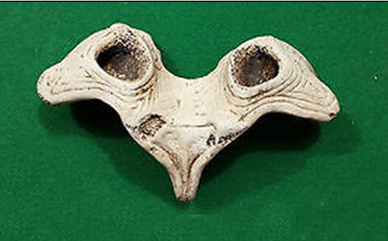

Am,C-Taino-Pendant-Owl-Bone-1000 CE

**Case No.: 18**

**Accession No.**

**Formal Label:** Am,C-Taino-Pendant-Owl-Bone-1000 CE

**Display Description:**

Cemi owls were likely gods or spiritual representatives important to Taino cosmological inquiry. The consensus is they were not simply naturalistic owls, but symbolic representations. Owls were associated with the afterlife and allies of the behique who sought their aid during hallucinogenic ventures.

**LC Classification:**

**Date or Time Horizon:**

**Geographical Area:**

**Map:**

**GPS coordinates:**

**Cultural Affiliation:**

**Media:**

**Dimensions: W 4.75 in**

**Weight:**

**Condition:**

**Provenance:**

**Discussion:**

**References:**